**Moveworks — AI Delivering The Future of Enterprise IT Automation**

[medium.com](https://medium.com/lightspeed-venture-partners/moveworks-ai-delivering-the-future-of-enterprise-it-automation-6e4d6af07f57)

Arif Janmohamed

5-6 minutes

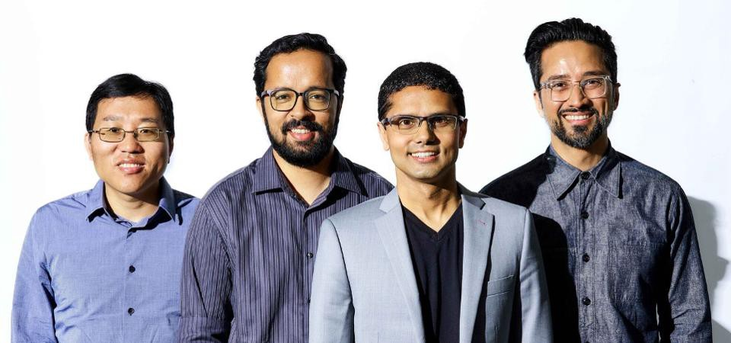

Moveworks Founders: Jiang Chen (Co-founder & VP Machine Learning), Vaibav Nivargi (Co-founder & CTO), Bhavin Shah (Co-founder & CEO), Varun Singh (Co-founder &VP Product)

[](https://medium.com/@arifj?source=post_page-----6e4d6af07f57--------------------------------)

It’s 8:30pm, the kids are in bed, and my wife logs back into her enterprise network to get some last minute work done. Actually, she tries to log back on, but for some reason her computer can’t connect. So, she tries to file a ticket with IT, but instead gets an auto-response that they are closed for the evening and would reply to the ticket within 48 hours… try calling the 800 number. After 45 mins of wasted time, she’s finally back online. And frustrated.

This scene replicates itself thousands of times a day in companies across the globe. And it’s not just network connections that don’t work. Employees need help from IT for many reasons — whether it’s provisioning new applications, finding the right form to fill out for a new computer or healthcare benefit, or answering questions about people, places or software. And until now, employees would have to file a ticket through an antiquated “web portal,” wait for up to 48 hours for an answer, or brave the helpdesk phone line.

Enter [Moveworks](http://www.moveworks.com/), a company changing the way enterprises resolve their employees’ problems.

Last week, [Moveworks](http://www.moveworks.com/) [emerged from stealth](https://www.forbes.com/sites/jilliandonfro/2019/04/17/moveworks-raises-30-million-to-automate-it-support-tasks/#4107a2711522) after raising $30M and investing 3 years to develop the next-generation of enterprise IT automation software. *Truly* powered by Artifical Intelligence (AI), Moveworks *instantly* resolves employee support issues in seconds, not days, through an intelligent conversational interface.

The Moveworks platform is modern and continuously improving, solves today’s CIO’s challenges, and delights employees with its elegance and simplicity. And Moveworks is already trusted by dozens of the world’s most innovative and demanding companies, including Broadcom, Nutanix and Autodesk.

Moveworks is a special company and it’s rare to see a company emerge from stealth mode in such an advanced state. The [Moveworks](http://www.moveworks.com/) [team](http://www.moveworks.com/about) has built a unique and technically advanced platform that delivers *truly autonomous* AI to take entire categories of work that have traditionally been done manually by people and automates them. And, unlike many other “AI startups”, the [Moveworks](http://www.moveworks.com/) platform already works in production, at scale, quietly and securely resolving 25% — 35% of IT support issues for thousands of people a day across dozens of companies.

[As I’ve written](https://medium.com/lightspeed-venture-partners/most-ai-companies-are-not-ai-companies-here-s-how-to-tell-746e8049daee), every startup today is positioning themselves as an AI company, but most are not. [Moveworks](http://www.moveworks.com/) is one of the few standouts that’s at the forefront of defining how enterprise software will evolve over the next decade. Unlike legacy software that is rules-based and requires expensive and time-intensive configuration, [Moveworks](http://www.moveworks.com/) leverages hundreds of machine-learning models that constantly improve their performance based on feedback loops and incremental data. Furthermore, Moveworks is up and running in a few weeks, doesn’t require anyone to run it and doesn’t require any on-site employee training or enablement. It just works. Like Magic.

Having now worked with the team from day one (first as a seed investor and then through the Series A with our friends at Bain Capital) and having been on the company’s Board of Directors for 3+ years, I have witnessed first hand how this company operates in radically different ways from most others. This team has truly leveraged machine learning to solve a real business problem… and they’ve done it in an elegant and delightful manner.

More exciting to me, I believe this team is not just rethinking IT support automation, but they are rethinking what it means to be an enterprise software company. 10 years from now, all market leading enterprise technology companies are going to look like [Moveworks](http://www.moveworks.com/). They will have to, otherwise they will be irrelevant.

At [Lightspeed](http://www.lsvp.com/), we’re extremely excited about our partnership with the [Moveworks](http://www.moveworks.com/) team as they truly leverage AI to transform and modernize the IT department and the broader world of enterprise software. They’re only 3 years old, but they’ve already accomplished a lot. And I’m excited to see what they continue to accomplish over the next decade. For more information on [Moveworks](http://www.moveworks.com/), visit [www.moveworks.com](http://www.moveworks.com/)

[*Arif Janmohamed*](http://lsvp.com/team/arif-janmohamed/) *is a Partner at* [*Lightspeed Venture Partners*](http://www.lsvp.com/)*. He lends significant enterprise cloud, AI and analytics expertise to the* [*Moveworks*](http://www.moveworks.com/) *team. In his free time, Arif plays ice hockey with his wife, who yells at him for never passing the puck to her.*